**AIM:**  **Android program based on Rest API.**

* **THEORY:**
  + **REST API:**

1. A REST API (also known as RESTful API) is an application programming interface (API or web API) that conforms to the constraints of REST architectural style and allows for interaction with RESTful web services.
2. REST stands for representational state transfer and was created by computer scientist Roy Fielding.
3. When a client request is made via a RESTful API, it transfers a representation of the state of the resource to the requester or endpoint.
4. This information, or representation, is delivered in one of several formats via HTTP: JSON (Javascript Object Notation), HTML, XLT, Python, PHP, or plain text. JSON is the most generally popular file format to use.
   * **HttpURLConnection:**
5. The Java HttpURLConnection class is http specific URLConnection.
6. It works for HTTP protocol only.
7. By the help of HttpURLConnection class, you can retrieve information of any HTTP URL such as header information, status code, response code etc.
8. The java.net.HttpURLConnection is subclass of URLConnection class.
   * **JSON Parsing:**
9. JSON (JavaScript Object Notation) is a lightweight, text-based, language-independent data exchange format that is easy for humans and machines to read and write.
10. JSON can represent two structured types: objects and arrays.
11. An object is an unordered collection of zero or more name/value pairs.
12. An array is an ordered sequence of zero or more values.
13. The GSON JsonParser class can parse a JSON string or stream into a tree structure of Java objects.
14. GSON also has two other parsers.
15. The Gson JSON parser which can parse JSON into Java objects, and the JsonReader which can parse a JSON string or stream into tokens (a pull parser).
    * **Volley:**
16. Volley is an HTTP library that makes networking very easy and fast, for Android apps.
17. It was developed by Google and introduced during Google I/O 2013.
18. It was developed because there is an absence in Android SDK, of a networking class capable of working without interfering with the user experience.
19. Although Volley is a part of the Android Open-Source Project (AOSP), Google announced in January 2017 that Volley will move to a standalone library.
20. It manages the processing and caching of network requests and it saves developers valuable time from writing the same network call/cache code again and again.
    * **Retrofit:**
21. Retrofit is a type-safe REST client for Android, Java and Kotlin developed by Square.
22. The library provides a powerful framework for authenticating and interacting with APIs and sending network requests with OkHttp.
23. This library makes downloading JSON or XML data from a web API fairly straightforward.
24. Once the data is downloaded then it is parsed into a Plain Old Java Object (POJO) which must be defined for each "resource" in the response.

**A) Create a basic application that allows you to download HTML from a given web page using HttpURLConnection.**

* **CODE:**
  + **activity_main.xml:**

<?xml version="1.0" encoding="utf-8"?>  
<androidx.constraintlayout.widget.ConstraintLayout xmlns:android="http://schemas.android.com/apk/res/android"  
 xmlns:app="http://schemas.android.com/apk/res-auto"  
 xmlns:tools="http://schemas.android.com/tools"  
 android:layout_width="match_parent"  
 android:layout_height="match_parent"  
 tools:context=".MainActivity">  
  
 <Button  
 android:id="@+id/button"  
 android:layout_width="wrap_content"  
 android:layout_height="wrap_content"  
 android:text="SUBMIT"  
 android:onClick="onClick"  
 app:layout_constraintBottom_toBottomOf="parent"  
 app:layout_constraintEnd_toEndOf="parent"  
 app:layout_constraintHorizontal_bias="0.498"  
 app:layout_constraintStart_toStartOf="parent"  
 app:layout_constraintTop_toTopOf="parent"  
 app:layout_constraintVertical_bias="0.174" />  
  
 <EditText  
 android:id="@+id/get_url"  
 android:layout_width="358dp"  
 android:layout_height="41dp"  
 android:ems="10"  
 android:hint="Enter URL"  
 android:inputType="textPersonName"  
 android:textAlignment="center"  
 android:textStyle="bold"  
 app:layout_constraintBottom_toBottomOf="parent"  
 app:layout_constraintEnd_toEndOf="parent"  
 app:layout_constraintHorizontal_bias="0.497"  
 app:layout_constraintStart_toStartOf="parent"  
 app:layout_constraintTop_toTopOf="parent"  
 app:layout_constraintVertical_bias="0.051" />  
  
 <TextView  
 android:id="@+id/textView"  
 android:layout_width="359dp"  
 android:layout_height="482dp"  
 android:text=""  
 android:scrollbars = "vertical"  
 app:layout_constraintBottom_toBottomOf="parent"  
 app:layout_constraintEnd_toEndOf="parent"  
 app:layout_constraintHorizontal_bias="0.497"  
 app:layout_constraintStart_toStartOf="parent"  
 app:layout_constraintTop_toTopOf="parent"  
 app:layout_constraintVertical_bias="0.816" />  
</androidx.constraintlayout.widget.ConstraintLayout>

* + **MainActivity.java:**

package com.example.practical8_a;  
  
import androidx.appcompat.app.AppCompatActivity;  
import android.content.Context;  
import android.os.Bundle;  
import android.view.View;  
import android.widget.Button;  
import android.widget.EditText;  
import android.widget.TextView;  
import android.widget.Toast;  
import java.io.BufferedReader;  
import java.io.FileNotFoundException;  
import java.io.FileOutputStream;  
import java.io.IOException;  
import java.io.InputStream;  
import java.io.InputStreamReader;  
import java.net.HttpURLConnection;  
import java.net.MalformedURLException;  
import java.net.URL;  
  
public class MainActivity extends AppCompatActivity {  
EditText e1;  
Button b;  
TextView t1;  
String data;  
 @Override  
 protected void onCreate(Bundle savedInstanceState) {  
 super.onCreate(savedInstanceState);  
 setContentView(R.layout.*activity_main*);  
 e1=findViewById(R.id.*get_url*);  
 b=findViewById(R.id.*button*);  
 t1 = findViewById(R.id.*textView*);  
 }  
 public void onClick(View view) throws IOException {  
 Thread thread = new Thread(new Runnable() {  
 @Override  
 public void run() {  
 try {  
 String link = e1.getText().toString();  
 //String link ="http://www.google.com";  
 URL url = new URL(link);  
 HttpURLConnection conn = (HttpURLConnection) url.openConnection();  
 conn.connect();  
 InputStream is = conn.getInputStream();  
 BufferedReader reader = new BufferedReader(new InputStreamReader(is, "UTF-8"));  
 String webPage = "",data="";  
 while ((data = reader.readLine()) != null){  
 webPage += data + "\n";  
 }  
 String filename="download.txt";  
 FileOutputStream fos;  
 try {  
 fos = openFileOutput(filename, Context.*MODE_APPEND*);  
 //default mode is PRIVATE, can be APPEND etc.  
 fos.write(webPage.getBytes());  
 fos.close();  
 t1.setText("SAVED TO FILE");  
 } catch (FileNotFoundException e) {Toast.*makeText*(getApplicationContext(),"FILE NOT FOUND",  
 Toast.*LENGTH_LONG*).show();;}  
 catch (IOException e) {e.printStackTrace();}  
 } catch (Exception e)  
 {  
 e.printStackTrace();  
 } }});  
 thread.start();

}}

* **OUTPUT:**

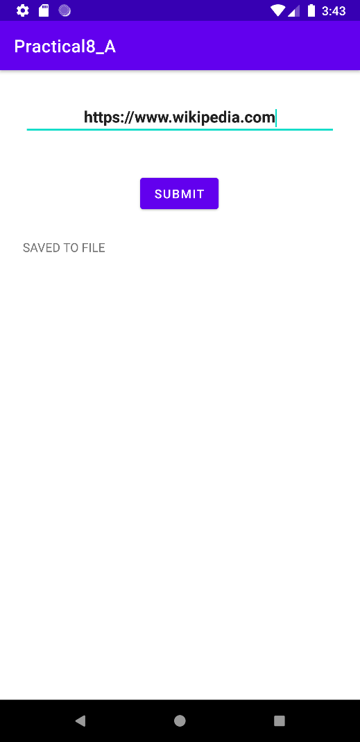

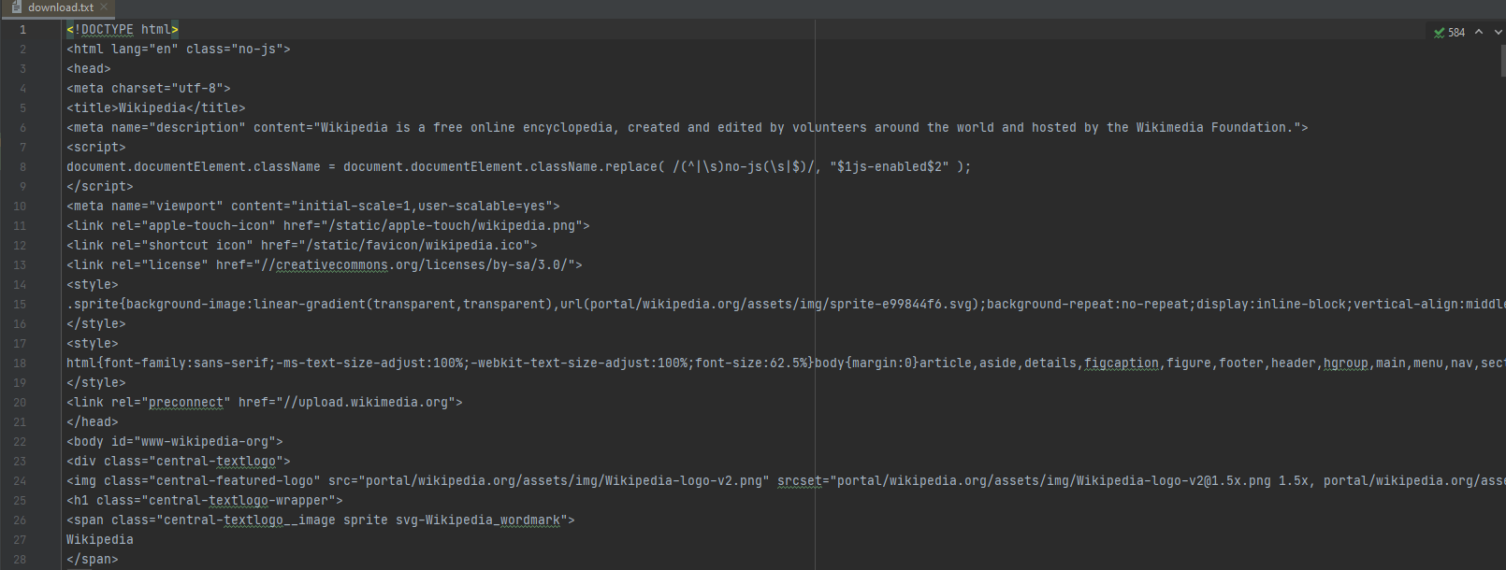

**B) Create an application to parse the data using JSONObject methods and set it in the Text View’s. (Employee name and salary stored in JSON format)**

* **CODE:**
  + **activity_main.xml:**

<?xml version="1.0" encoding="utf-8"?>  
<androidx.constraintlayout.widget.ConstraintLayout xmlns:android="http://schemas.android.com/apk/res/android"  
 xmlns:app="http://schemas.android.com/apk/res-auto"  
 xmlns:tools="http://schemas.android.com/tools"  
 android:layout_width="match_parent"  
 android:layout_height="match_parent"  
 tools:context=".MainActivity">  
  
 <TextView  
 android:id="@+id/name"  
 android:layout_width="248dp"  
 android:layout_height="59dp"  
 android:layout_centerHorizontal="true"  
 android:text="Name"  
 android:textColor="#000"  
 android:textSize="20sp"  
 app:layout_constraintBottom_toBottomOf="parent"  
 app:layout_constraintEnd_toEndOf="parent"  
 app:layout_constraintHorizontal_bias="0.395"  
 app:layout_constraintStart_toStartOf="parent"  
 app:layout_constraintTop_toTopOf="parent"  
 app:layout_constraintVertical_bias="0.208" />  
  
 <TextView  
 android:id="@+id/salary"  
 android:layout_width="259dp"  
 android:layout_height="61dp"  
 android:layout_centerHorizontal="true"  
 android:text="Salary"  
 android:textColor="#000"  
 android:textSize="20sp"  
 app:layout_constraintBottom_toBottomOf="parent"  
 app:layout_constraintEnd_toEndOf="parent"  
 app:layout_constraintHorizontal_bias="0.377"  
 app:layout_constraintStart_toStartOf="parent"  
 app:layout_constraintTop_toTopOf="parent"  
 app:layout_constraintVertical_bias="0.381" />  
  
</androidx.constraintlayout.widget.ConstraintLayout>

* + **MainActivity.java:**

package com.example.practical8_b;  
  
import androidx.appcompat.app.AppCompatActivity;  
import android.os.Bundle;  
import android.widget.TextView;  
import org.json.JSONException;  
import org.json.JSONObject;  
  
public class MainActivity extends AppCompatActivity {  
 String JSON_STRING = "{\"employee\":{\"name\":\"ATHARVA KALE\",\"salary\":650000}}";  
 String name, salary;  
 TextView employeeName, employeeSalary;  
 @Override  
 protected void onCreate(Bundle savedInstanceState) {  
 super.onCreate(savedInstanceState);  
 setContentView(R.layout.activity_main);  
 employeeName = (TextView) findViewById(R.id.name);  
 employeeSalary = (TextView) findViewById(R.id.salary);  
  
 try {  
 JSONObject obj = new JSONObject(JSON_STRING);  
  
 JSONObject employee = obj.getJSONObject("employee");  
  
 name = employee.getString("name");  
 salary = employee.getString("salary");  
 employeeName.setText("Name: "+name);  
 employeeSalary.setText("Salary: "+salary);  
  
 } catch (JSONException e) {  
 e.printStackTrace();  
 }  
 }  
}

* **OUTPUT:**

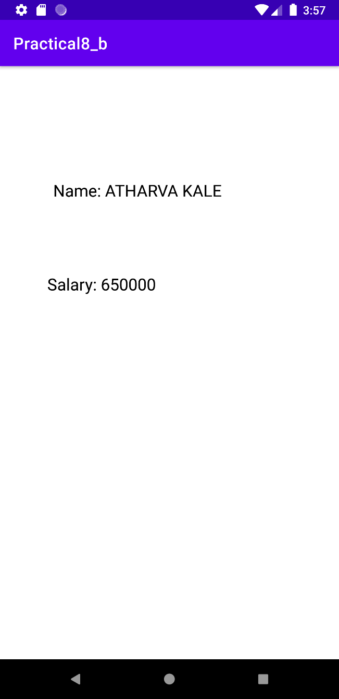

**C) Write a basic application to (use volley library), create a button and on click of the button a HTTP request will be send to server. The response from the server is then displayed using Toast on the screen.**

* **CODE:**
  + **activity_main.xml:**

<?xml version="1.0" encoding="utf-8"?>  
<androidx.constraintlayout.widget.ConstraintLayout xmlns:android="http://schemas.android.com/apk/res/android"  
 xmlns:app="http://schemas.android.com/apk/res-auto"  
 xmlns:tools="http://schemas.android.com/tools"  
 android:layout_width="match_parent"  
 android:layout_height="match_parent"  
 tools:context=".MainActivity">  
  
 <Button  
 android:id="@+id/buttonRequest"  
 android:layout_width="210dp"  
 android:layout_height="49dp"  
 android:layout_alignParentTop="true"  
 android:background="#414af4"  
 android:text="SUBMIT"  
 android:textColor="#ffffff"  
 app:layout_constraintBottom_toBottomOf="parent"  
 app:layout_constraintEnd_toEndOf="parent"  
 app:layout_constraintHorizontal_bias="0.494"  
 app:layout_constraintStart_toStartOf="parent"  
 app:layout_constraintTop_toTopOf="parent"  
 app:layout_constraintVertical_bias="0.735" />  
  
</androidx.constraintlayout.widget.ConstraintLayout>

* + **MainActivity.java:**

package com.example.practical8_c;  
  
import androidx.appcompat.app.AppCompatActivity;  
  
import android.os.Bundle;  
import android.util.Log;  
import android.view.View;  
import android.widget.Button;  
import android.widget.Toast;  
  
import com.android.volley.Request;  
import com.android.volley.RequestQueue;  
import com.android.volley.Response;  
import com.android.volley.VolleyError;  
import com.android.volley.toolbox.StringRequest;  
import com.android.volley.toolbox.Volley;  
  
public class MainActivity extends AppCompatActivity {  
 private static final String *TAG* = MainActivity.class.getName();  
 private Button btnRequest;  
  
 private RequestQueue mRequestQueue;  
 private StringRequest mStringRequest;  
 private String url = "https://run.mocky.io/v3/b0f7696f-ac67-4152-9f23-1a4c3dc68b37";  
 @Override  
 protected void onCreate(Bundle savedInstanceState) {  
 super.onCreate(savedInstanceState);  
 setContentView(R.layout.activity_main);  
 btnRequest = (Button) findViewById(R.id.buttonRequest);  
  
 btnRequest.setOnClickListener(new View.OnClickListener() {  
 @Override  
 public void onClick(View v){  
  
 sendAndRequestResponse();  
  
 }  
 }  
  
 );  
  
 }  
  
 private void sendAndRequestResponse() {  
  
 //RequestQueue initialized  
 mRequestQueue = Volley.newRequestQueue(this);  
  
 //String Request initialized  
 mStringRequest = new StringRequest(Request.Method.GET, url, new Response.Listener<String>() {  
 @Override  
 public void onResponse(String response) {  
  
 Toast.makeText(getApplicationContext(),"Response :" + response.toString(), Toast.LENGTH_LONG).show();//display the response on screen  
  
 }  
 }, new Response.ErrorListener() {  
 @Override  
 public void onErrorResponse(VolleyError error) {  
  
 Log.i(TAG,"Error :" + error.toString());  
 }  
 });  
  
 mRequestQueue.add(mStringRequest);  
 }  
}

* **OUTPUT:**

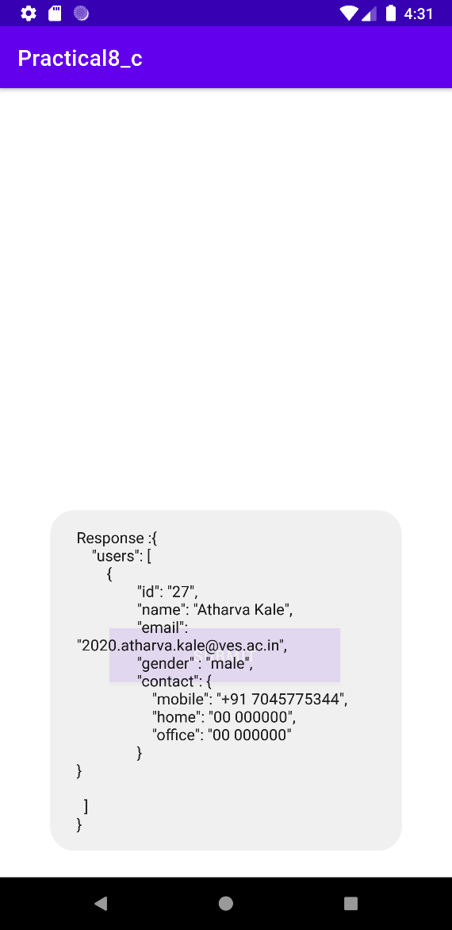

**D) Write a program to create sign up page design with 3 Edit Texts (Name, email and password) and one sign up Button. On click of button, data in EditText is validated. Implement signup api to save the data in database. After getting response from api display the message on the screen by using a Toast. (useRetrofit)**

* **CODE:**
  + **activity_main.xml:**

<?xml version="1.0" encoding="utf-8"?>  
<androidx.constraintlayout.widget.ConstraintLayout xmlns:android="http://schemas.android.com/apk/res/android"  
 xmlns:app="http://schemas.android.com/apk/res-auto"  
 xmlns:tools="http://schemas.android.com/tools"  
 android:layout_width="match_parent"  
 android:layout_height="match_parent"  
 tools:context=".MainActivity">  
  
 <EditText  
 android:id="@+id/name"  
 android:layout_width="314dp"  
 android:layout_height="44dp"  
 android:ems="10"  
 android:hint="Enter Name"  
 android:imeOptions="actionNext"  
 android:inputType="textPersonName"  
 android:textColor="#E91E63"  
 android:textStyle="bold"  
 app:layout_constraintBottom_toBottomOf="parent"  
 app:layout_constraintEnd_toEndOf="parent"  
 app:layout_constraintHorizontal_bias="0.238"  
 app:layout_constraintStart_toStartOf="parent"  
 app:layout_constraintTop_toTopOf="parent"  
 app:layout_constraintVertical_bias="0.323" />  
  
 <EditText  
 android:id="@+id/email"  
 android:layout_width="314dp"  
 android:layout_height="44dp"  
 android:ems="10"  
 android:hint="Enter E-Mail"  
 android:imeOptions="actionNext"  
 android:inputType="textEmailAddress"  
 android:textColor="#E91E63"  
 android:textStyle="bold"  
 app:layout_constraintBottom_toBottomOf="parent"  
 app:layout_constraintEnd_toEndOf="parent"  
 app:layout_constraintHorizontal_bias="0.237"  
 app:layout_constraintStart_toStartOf="parent"  
 app:layout_constraintTop_toTopOf="parent"  
 app:layout_constraintVertical_bias="0.442" />  
  
 <EditText  
 android:id="@+id/pass"  
 android:layout_width="314dp"  
 android:layout_height="44dp"  
 android:ems="10"  
 android:hint="Enter Password"  
 android:imeOptions="actionDone"  
 android:inputType="textPassword"  
 android:textColor="#E91E63"  
 android:textStyle="bold"  
 app:layout_constraintBottom_toBottomOf="parent"  
 app:layout_constraintEnd_toEndOf="parent"  
 app:layout_constraintHorizontal_bias="0.237"  
 app:layout_constraintStart_toStartOf="parent"  
 app:layout_constraintTop_toTopOf="parent"  
 app:layout_constraintVertical_bias="0.573" />  
  
 <Button  
 android:id="@+id/button"  
 android:layout_width="149dp"  
 android:layout_height="59dp"  
 android:text="SUBMIT"  
 android:textColor="#E91E63"  
 android:textSize="20sp"  
 android:textStyle="bold"  
 app:layout_constraintBottom_toBottomOf="parent"  
 app:layout_constraintEnd_toEndOf="parent"  
 app:layout_constraintStart_toStartOf="parent"  
 app:layout_constraintTop_toTopOf="parent"  
 app:layout_constraintVertical_bias="0.787" />  
  
</androidx.constraintlayout.widget.ConstraintLayout>

* + **MainActivity.java:**

package com.example.prac8;  
  
import androidx.appcompat.app.AppCompatActivity;  
  
import android.os.Bundle;  
import android.util.Log;  
import android.util.Patterns;  
import android.view.View;  
import android.widget.Button;  
import android.widget.EditText;  
import android.widget.Toast;  
  
import java.io.IOException;  
  
import okhttp3.ResponseBody;  
import retrofit2.Call;  
import retrofit2.Callback;  
import retrofit2.Response;  
  
public class MainActivity extends AppCompatActivity {  
 private EditText nameEdt, emailEdt,passEdt;  
 private Button postDataBtn;  
 @Override  
 protected void onCreate(Bundle savedInstanceState) {  
 super.onCreate(savedInstanceState);  
 setContentView(R.layout.activity_main);  
 nameEdt = findViewById(R.id.name);  
 emailEdt = findViewById(R.id.email);  
 passEdt = findViewById(R.id.pass);  
 postDataBtn = findViewById(R.id.button);  
 postDataBtn.setOnClickListener(new View.OnClickListener() {  
 @Override  
 public void onClick(View v) {  
// validating if the text field is empty or not.  
  
 validateUserData();  
 }  
 });  
 }  
 private void validateUserData() {  
//find values  
 final String reg_name = nameEdt.getText().toString();  
 final String reg_email = emailEdt.getText().toString();  
 final String reg_password = passEdt.getText().toString();  
 if (reg_name.isEmpty() || reg_name.equals(null)) {  
 nameEdt.setError("Please enter username");  
 nameEdt.requestFocus();  
 }  
 else if (!Patterns.EMAIL_ADDRESS.matcher(reg_email).matches()) {  
 emailEdt.setError("Please enter email");  
 emailEdt.requestFocus();  
 }  
 else if (reg_password.isEmpty()) {  
 passEdt.setError("Please enter password");  
 passEdt.requestFocus();  
 }  
 else {  
 Call<ResponseBody> call = RetrofitClient.getmInstance().getApi().createUser(reg_name, reg_email, reg_password);  
 call.enqueue(new Callback<ResponseBody>() {  
 @Override  
 public void onResponse(Call<ResponseBody> call,  
 Response<ResponseBody> response) {  
 try {  
 String s = response.body().string().trim();  
 Log.d("data", s);  
 Toast.makeText(MainActivity.this, s,  
 Toast.LENGTH_SHORT).show();  
 } catch (IOException e) {  
 e.printStackTrace();  
 }  
 }  
  
  
  
 @Override  
 public void onFailure(Call<ResponseBody> call, Throwable t) {  
 Toast.makeText(MainActivity.this, t.getMessage(),  
 Toast.LENGTH_SHORT).show();  
 }  
 });  
 }  
 }  
}

* + **RetrofitClient.java:**

package com.example.prac8;  
  
import java.io.IOException;  
import java.io.InputStream;  
import java.security.KeyStore;  
import java.security.KeyStoreException;  
import java.security.NoSuchAlgorithmException;  
import java.security.SecureRandom;  
import java.security.cert.Certificate;  
import java.security.cert.CertificateException;  
import java.security.cert.CertificateFactory;  
import java.security.cert.X509Certificate;  
  
import javax.net.ssl.HostnameVerifier;  
import javax.net.ssl.HttpsURLConnection;  
import javax.net.ssl.SSLContext;  
import javax.net.ssl.SSLSession;  
import javax.net.ssl.SSLSocketFactory;  
import javax.net.ssl.TrustManager;  
import javax.net.ssl.TrustManagerFactory;  
import javax.net.ssl.X509TrustManager;  
  
import okhttp3.OkHttpClient;  
import retrofit2.Retrofit;  
import retrofit2.converter.gson.GsonConverterFactory;  
public class RetrofitClient {  
 private static final String *BASE_URL* = "https://chorioid-hilltop.000webhostapp.com/test_android/";  
 private static RetrofitClient *mInstance*;  
 private Retrofit retrofit;  
 private RetrofitClient() {  
 retrofit = new Retrofit.Builder().baseUrl(*BASE_URL*)  
 .addConverterFactory(GsonConverterFactory.*create*())  
 .build();  
  
 }  
 public static synchronized RetrofitClient getmInstance(){  
 if(*mInstance* == null){  
 *mInstance* = new RetrofitClient();  
 }  
 return *mInstance*;  
 }  
 public Api getApi(){  
 return retrofit.create(Api.class);  
 }  
  
}

* + **Api.java:**

package com.example.prac8;  
  
import okhttp3.ResponseBody;  
import retrofit2.Call;  
import retrofit2.http.Field;  
import retrofit2.http.FormUrlEncoded;  
import retrofit2.http.POST;  
  
  
public interface Api {  
 @FormUrlEncoded  
 @POST("insert.php")  
 Call<ResponseBody> createUser(  
 @Field("name") String name,  
 @Field("email") String email,  
 @Field("pwd") String password  
 );  
}

* **OUTPUT:**
  + **GUI Validation**

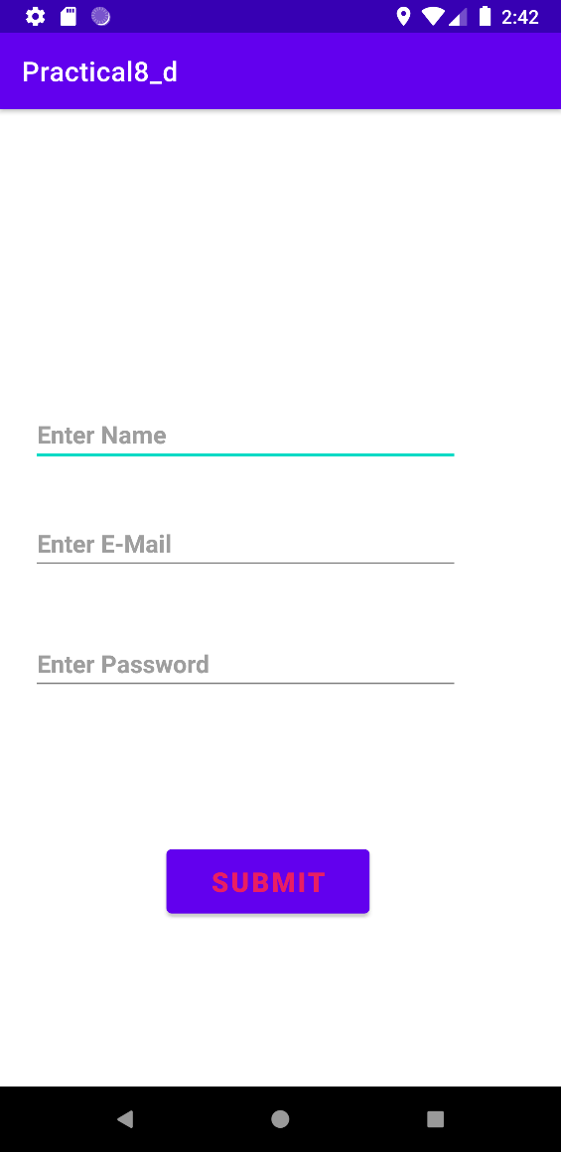 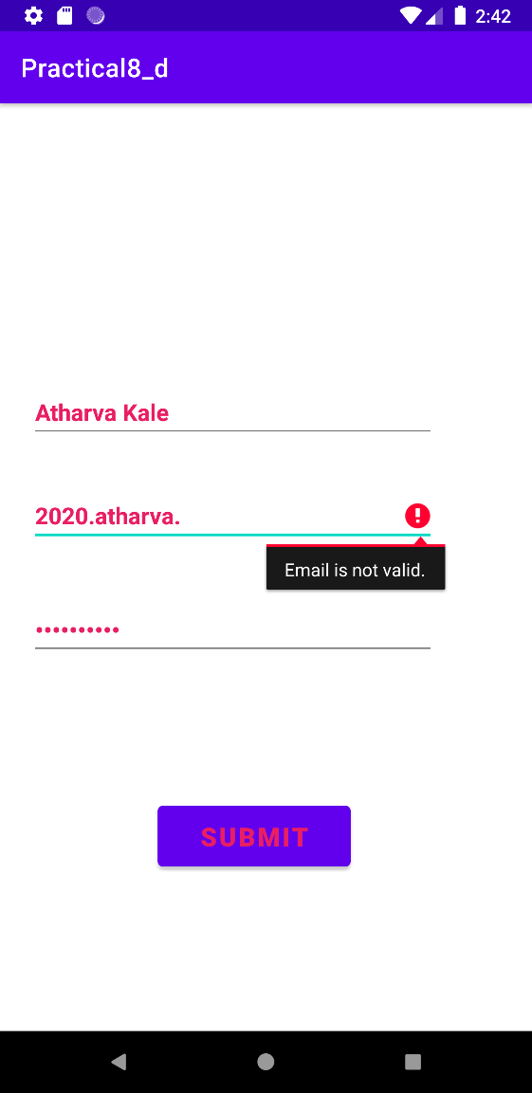

* + **Data Save Database**

**F:\ANDROID OP\Screenshot 2021-11-27 000946.png**

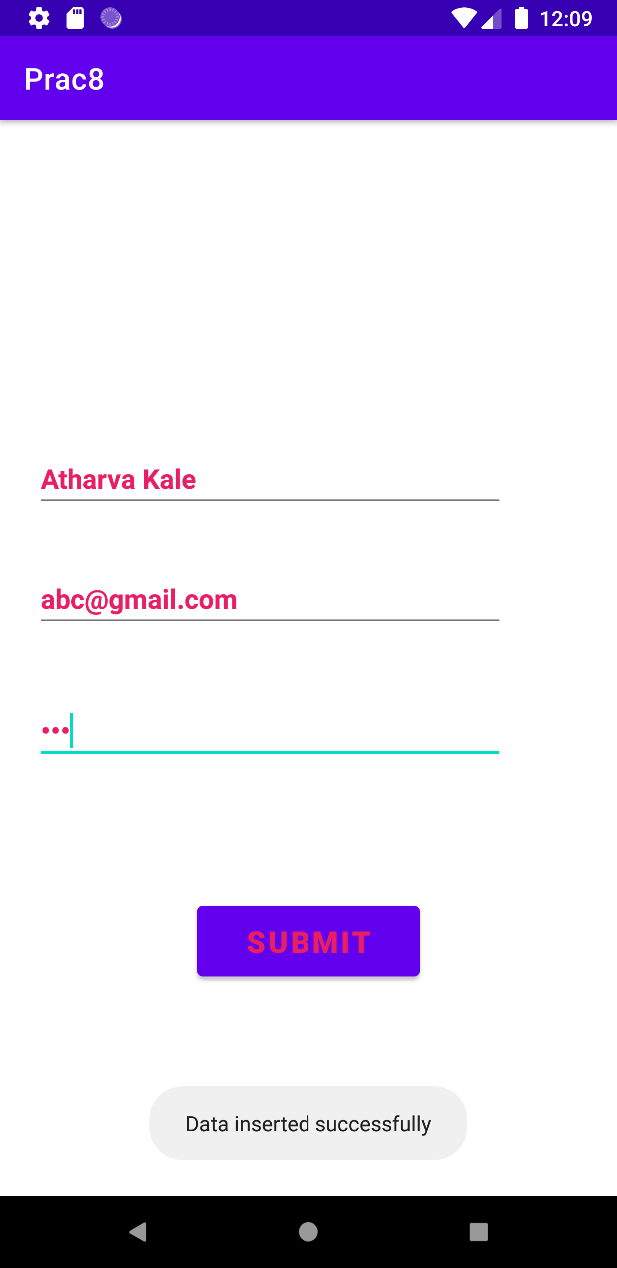

* **CONCLUSION:**

Hence we successfully implemented Rest API.